**Python Crypto Assignment 1:**

**Visualizing Crypto Price Data using Line chart**

While investing in cryptos, it is important for an investor to visualize the volatility of the price and the price trend using the line chart.

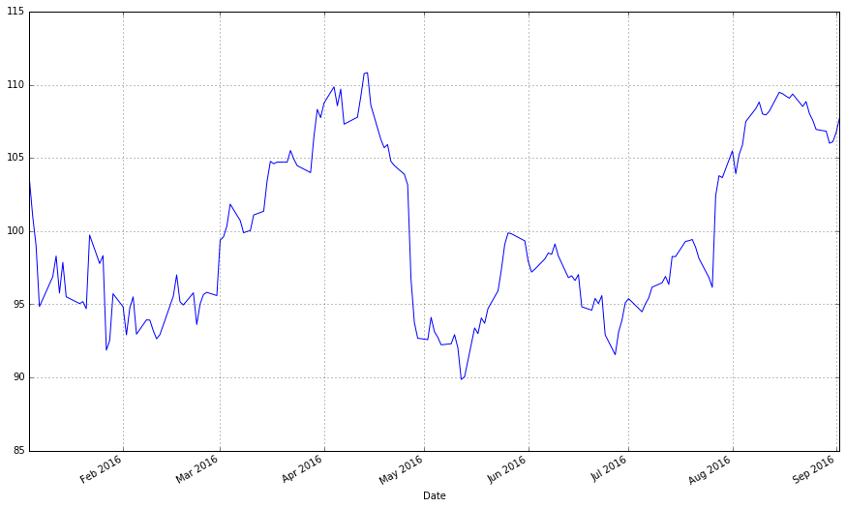

Your assignment is to draw a price line chart in Python using matplotlib and realtime price data for Bitcoin and Ethereum.

The line chart should show historical data price data and should update itself after every few minutes.

**Step One: Get Bitcoin and Ethereum Price Data**

There are a lot of sources to get historic data for crypto prices:

<https://www.quora.com/Where-can-I-get-historical-raw-data-on-Bitcoin-price-and-volume-across-different-exchanges>

<https://bitcoin.stackexchange.com/questions/36088/where-can-i-find-historical-price-of-altcoins>

<https://coinmetrics.io/data-downloads/>

You can also download the realtime price data using Python API’s:

<http://blockxchain.org/2017/09/05/getting-started-with-the-cryptocompare-api-in-python/>

<https://medium.com/@agalea91/cryptocompare-api-quick-start-guide-ca4430a484d4>

**Step Two: Draw Line Charts for Historical Prices**

**Step Three: Update the Line Charts every few minutes using the Latest Prices**

Learning References:

<https://stackoverflow.com/questions/645312/what-is-the-quickest-way-to-http-get-in-python>

<https://www.geeksforgeeks.org/get-post-requests-using-python/>

<https://pythonspot.com/matplotlib-line-chart/>

<https://plot.ly/matplotlib/plot/>

<https://stackoverflow.com/questions/39715601/how-to-create-a-line-chart-using-matplotlib>

Examples of Price Charts:

<https://www.worldcoinindex.com/coin/bitcoin>

<https://www.coindesk.com/ethereum-price/>